## 

* The prescribed textbook may be referenced.
* Your name, student number, project number and date of submission must be included on the document’s cover page.
* Software requirements: o GNS3 Software 2.1.8 or higher o GNS3 VMware 2.1.8 or higher (make sure the version matches with the GNS3 software) o VMware Workstation or Player (version 12 recommended) o Windows Server 2019 Desktop Experience Standard Edition o

Windows Server 2016 Desktop Experience Standard Edition o Windows 10 Enterprise

Edition o Cisco 3745 Router image

# Section A

## Question 1 32 Marks

Study the scenarios and complete the question(s) that follow:

**Scenario 1**

Enterprises should rely on the collaborative standards-making process to ensure a strong foundation of security. You will consider the different standards and best practices that are out there and how they can help shape your own security strategies to help mitigate risk in your enterprise. Source: Nufryk, J. 2018. *The Official CompTIA Advanced Security Practitioner (CASP+) Student Guide (Exam CAS-003).* Downers Grove,

Illinois: CompTIA

1.1

1. What are some of the important factors to consider when choosing security standards

to implement in the enterprise? (4 Marks)

1. As an Information Security Officer of Delware Inc., you have updated the security standards to meet enterprise risk management (ERM) requirements. With these standards in mind, what sort of interoperability issues might there be in legacy

systems? (4 Marks)

1. Assuming Delware Inc. acquires a smaller competitor, how might this bring additional

risk to the organisation from a personal standpoint? (4 Marks)

1. Five years ago, Delware Inc. purchased and deployed a network IDS from one vendor. The company purchased multiple types of host-based IPSes over a period of two years from a second vendor. Just recently, they purchased a brand new SIEM appliance from a third vendor. To improve its data collection, analysis and reporting processes, the organisation wants the SIEM to correlate and aggregate data from the IDS/IPS solutions. This should, overall, improve its resiliency in the face of threats.

However, what issues or obstacles to this resilience tactic do you see? (4 Marks)

**[Sub Total 16 Marks]**

**Scenario 2**

The design of your network at Delware is just as important as the specific devices you choose to implement. Being able to analyse design concepts like IPv6, mesh networking, software-defined networking and more will help you take a holistic approach to securing your network.

Source: Nufryk, J. 2018. *The Official CompTIA Advanced Security Practitioner (CASP+) Student Guide (Exam CAS-003).* Downers Grove,

Illinois: CompTIA

1.2

1. Briefly discuss the advantages of using IPv6 over IPv4. (4 Marks)
2. Explain the security issues you need to consider when implementing an 802.1x

infrastructure. (4 Marks)

1. Delware’s network engineers have raised concerns that the company’s current configuration is putting the network at risk of unacceptable downtime. They suggest converting to a mesh configuration to solve this problem. What are your thoughts and concerns with this suggestion? (4 Marks) d. What are some of the security implications of using SDN? (4 Marks)

**[Sub Total 16 Marks]**

End of Question 1

## Question 2 68 Marks

2.1 Create a virtual lab environment using GNS3. The lab should consist of the following:

* Windows Sever 2019 Standard Edition
* Windows Server 2016 Standard Edition
* Windows 10 Enterprise Edition
* Cisco IOS router

* 1. Set up the lab to resemble the image below: (12 Marks)

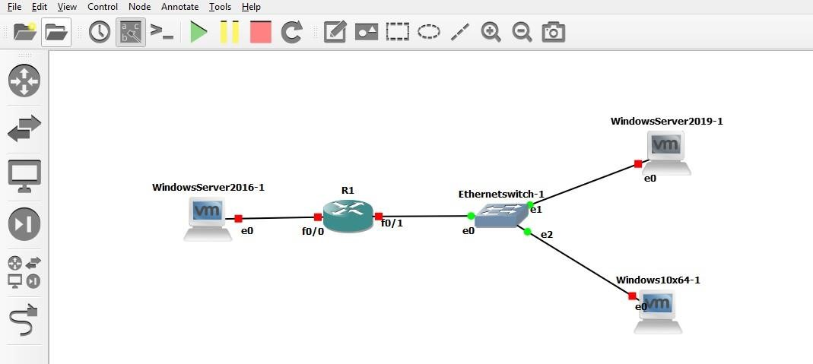

**Figure 1 – GNS3 setup**

* 1. Configure a static IP address on both the router interfaces. The router will act as a gateway for the two forests. (8 Marks)

* 1. Both the servers must be configured in two different forests and different networks.
* Windows Server 2019 must be a domain controller in the syntech.co.za forest.

(8 Marks)

* Windows Server 2016 must be a domain controller in the adatum.org.za forest.

(8 Marks)

* 1. Windows 10 must be joined to the syntech.co.za domain. (2 Marks)

* 1. Create a Group Policy on Windows Server 2019 to enforce the following:
* A strong password policy, which includes lockout threshold, minimum and maximum password age. (6 Marks)
* The Control Panel must be disabled on all client computers. (2 Marks)
* The Password Reveal button must be disabled on all computers. (2 Marks)

2.7 Using Active Directory Domains and Trusts, establish a trust relationship between the two forests. Use two-way trust. (20 Marks)

End of Question 2